Mars 12, 2018

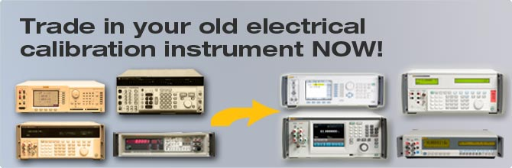
REP ALERT
Trade-In Promotion for Electrical Calibration
Instruments

Time frame
February 15th – May 31st , 2018
Trade-in list
New Fluke Calibration unit | Trade-in unit | Discount %
Electrical Calibrator
5502A Multi-Product Calibrator* | 5500A, 5520A, 5700/5720A, 9500  or  Any Fluke / Wavetek-Datron Electrical Calibrator | 15%
5522A Multi-Product Calibrator*
5730A Multifunction Calibrator*
9500B Oscilloscope Calibrator*
One of the above against | Any equivalent non-Fluke/Wavetek-Datron Electrical Calibrator | 20%
Precision Digital Multimeters
8508A  8508A/01  8,5 Digit Reference Multimeters* | Fluke 8500A, 8502A, 8505A, 8506A  Datron/Wavetek 1061, 1071, 1081, 1281 | 15%
One of the above against | Any equivalent non-Fluke Wavetek-Datron 6.5 digit or more Precision Digital Multimeters  like e.g  Solartron 7081  HP/Agilent 3458 | 20%
RF Calibrators - Signal Generators
96270A RF Reference Source* | Fluke 9640A Reference Sources or any other Fluke Reference Sources* | 15%
The above against | Any equivalent non-Fluke Wavetek-Datron Signal Generators like e.g.:  - HP3335A, HP8662A, HP8663A, HP8340A, HP8360 B-Series  - Agilent E8257 Series  - Other equivalent competitor's signal generators or RF Sources | 20%
*in all configurations

