How to setup a User/Contact and allow them access to the Customer Portal.

You need to create a User
Then create a Contact
And then associate the User to the Contact.

The steps below outline this process:

To create a new user account to login to Customer Portal, you would need to follow the steps below:
1. First use MET/TEAM to create a user.
A) Login MET/TEAM as administrator. Administrator will allow you add/delete user or contact accounts.
B) Click Setup from menu bar, then click Users in the dropdown list. Click Add button to add a new user account.
C) In the pop up Add User window, type in First, Last, Initials, Username, PortalUserNew in the sample, and Password. Click Save button at the top menu bar.
Note the below window is Edit User not Add User, because the screen shot was taken after the user was created.
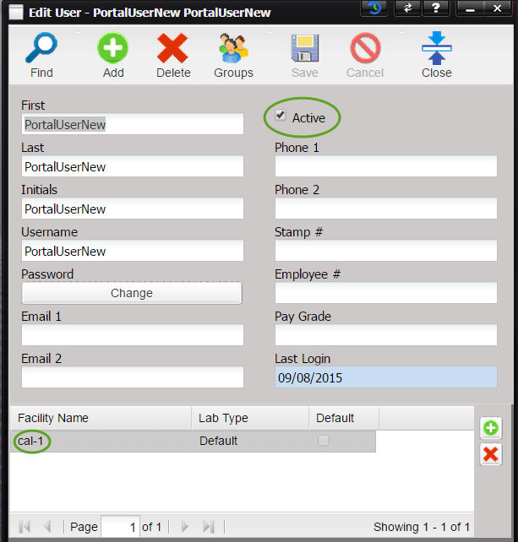
D) An Attention message box will pop up and ask you to select a lab to associate with this user. Click the OK button, which will pop up the Find New Lab window.
E) Click Find button from menu bar and then choose the lab from the list, cal-1 in the sample. You could see the lab name was listed under the Facility Name at the bottom of the Edit User window.
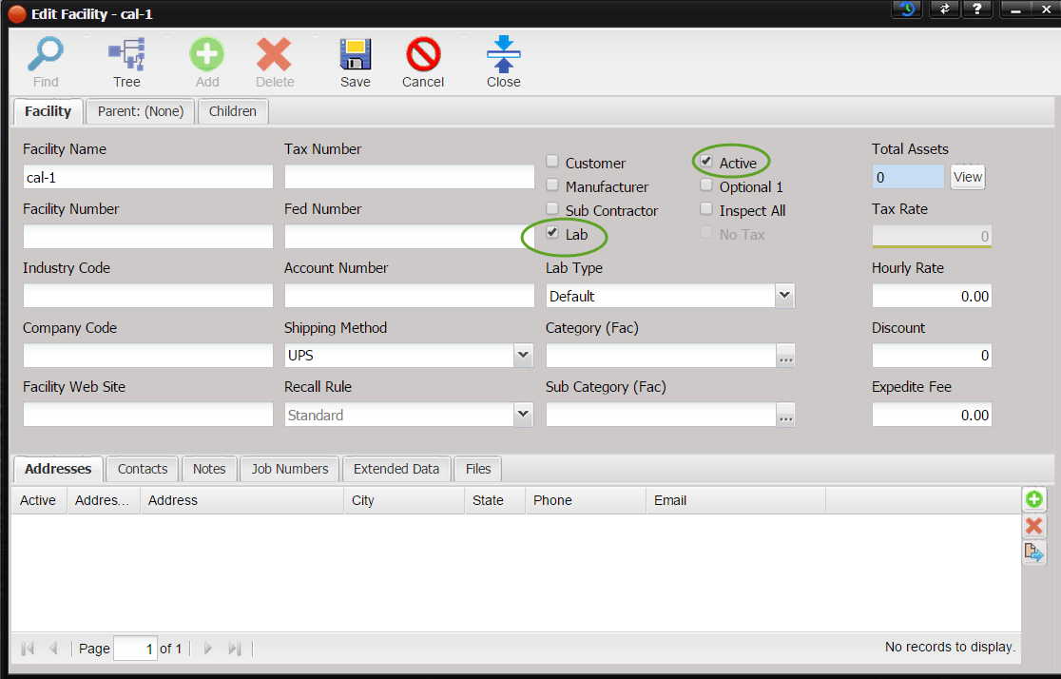
F) And now click the Group button from the Edit User window's menu bar to pop up the Assign Groups window. Check the Customer Portal checkbox, click Save button and close the Assign Groups window.

2. After creating a new user, next, you need to add a contact to associate with the user account.
A) Click Setup from MET/TEAM menu bar and click Contacts from the dropdown list. Click the Add button from the Find Contact window to create a new contact.
B) In Add Contact window, type in the Contact ID, and other infor, like First Name and Last Name, PortalContactNew in sample.
C) Now, you would need to associate a user to this contact by clicking the ellipsis after the User textbox. In Find User popup window, click Find button and choose the user that we just added, PortalUserNew. And click Save button to save the contact info.
D) After that, click the little Add Facility button on the bottom right to add a facility. In this sample, click the Find button in the Find Facility window and highlight the facility name in the list, cal-1, and then click OK button.
E) Uncheck the Lab checkbox and check the Customer checkbox. And click Save button.
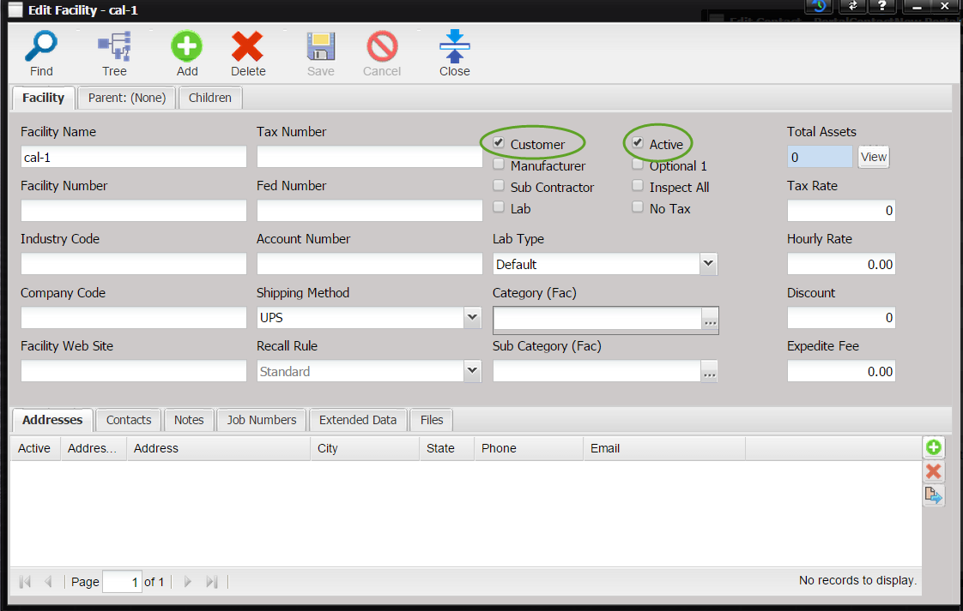
And the Add Contact window will look like below:
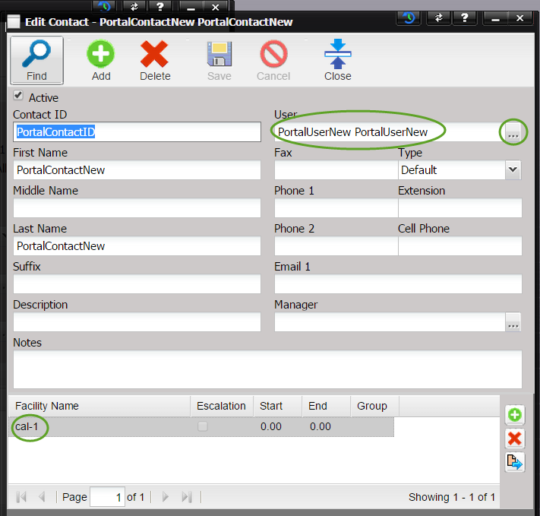
Note the screen shot was taken after the contact was created, so instead of Add Contact, you see Edit Contact in title.
3. The last step is to go to Customer Portal, and try to login using the just created user login name, PortalUserNew, and password

